A Parish Health Model -- Overview
Common Sense Good Practice Inventory for Building Healthy Orthodox Parishes
The Orthodox Church in America’s Diocese of the Midwest’s recent Parish Health Summit brought together 15 Orthodox priests from 12 growing parishes.
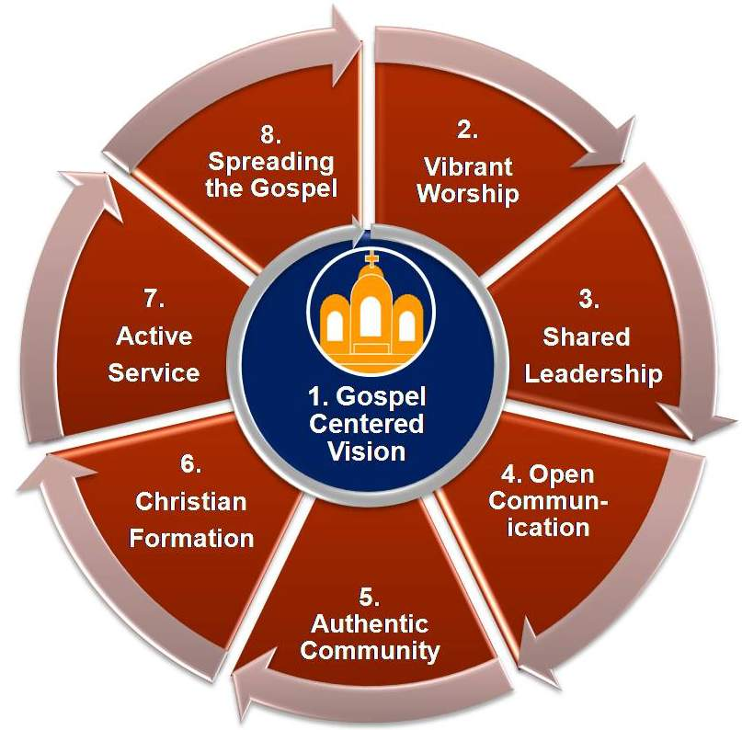
Figure 1 The Parish Health Model
After two days of exploring what is working and not working when it comes to building healthy American Orthodox parishes, attendees discussed how best to share the fruits of their discussions with other Orthodox parishes that were not in attendance.
It was decided to define a clear set of essential "focus areas" -- dimensions of parish life and practice that were consistent with the lived experience of parishes represented at the Summit -- in hopes that this could serve as a model for parishes to apply to their particular situation.
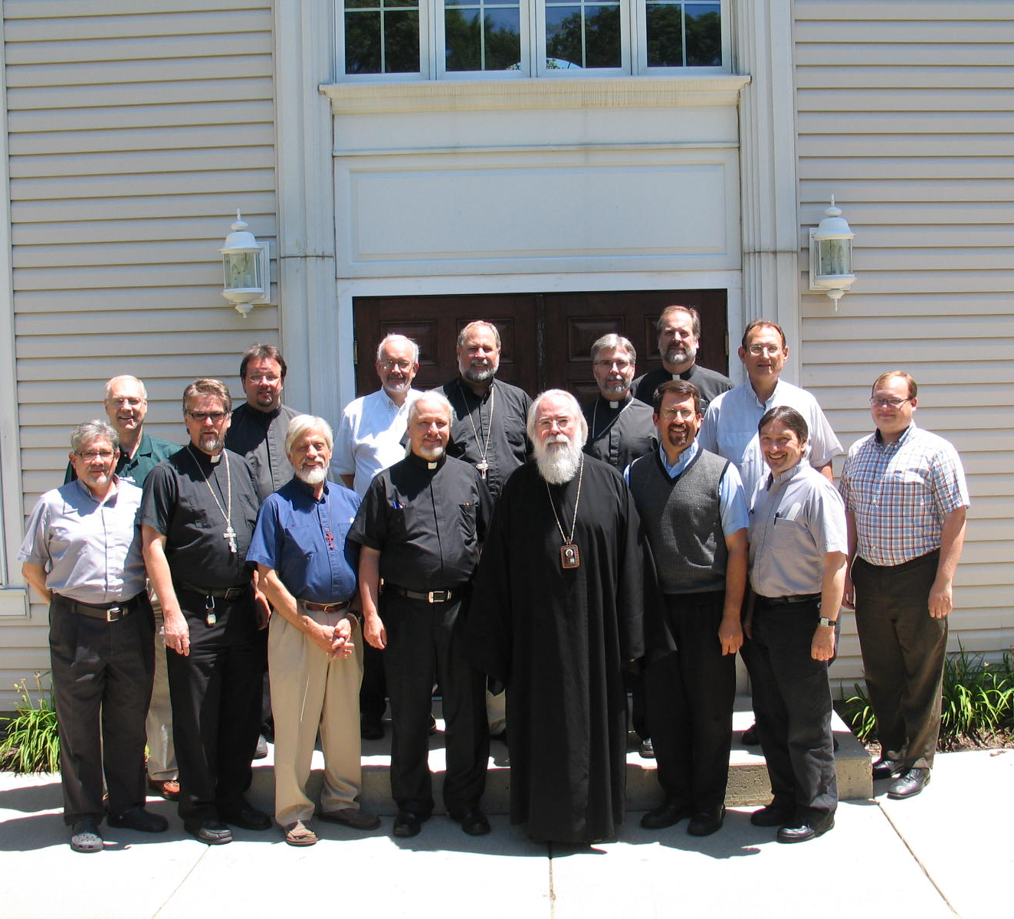
After receiving nominations from each attendee, the list was reviewed, clustered, combined, renamed, and discussed. After spirited debate the group converged on eight essential areas for building health and vibrancy in Orthodox parishes. Considerable effort was then put forth to describe these areas with supporting detail.
Attendees at Parish Health Summit

Eight Essential Focus: Areas an Overview

1. Gospel Centered Vision
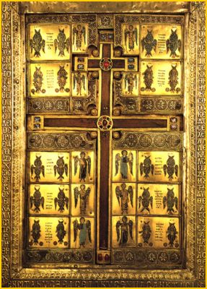
⬥ Mission, Vision & Identity  Parish Self Awareness & Understanding
⬥ Atmosphere of Excellence Growth & Replication

A healthy parish clearly understands that its reason for existence is to serve the Living God and to share its love of God with others. This vision provides a foundation for how it behaves, how it presents itself to its neighbors and what it truly values. The vision is based on a realistic context that integrates its past, its assets, strengths, limitations and environment.

2. Vibrant Worship
⬥ Liturgical Preparedness  Congregational Participation
⬥ Effective Preaching  Appropriate Worship Cycles
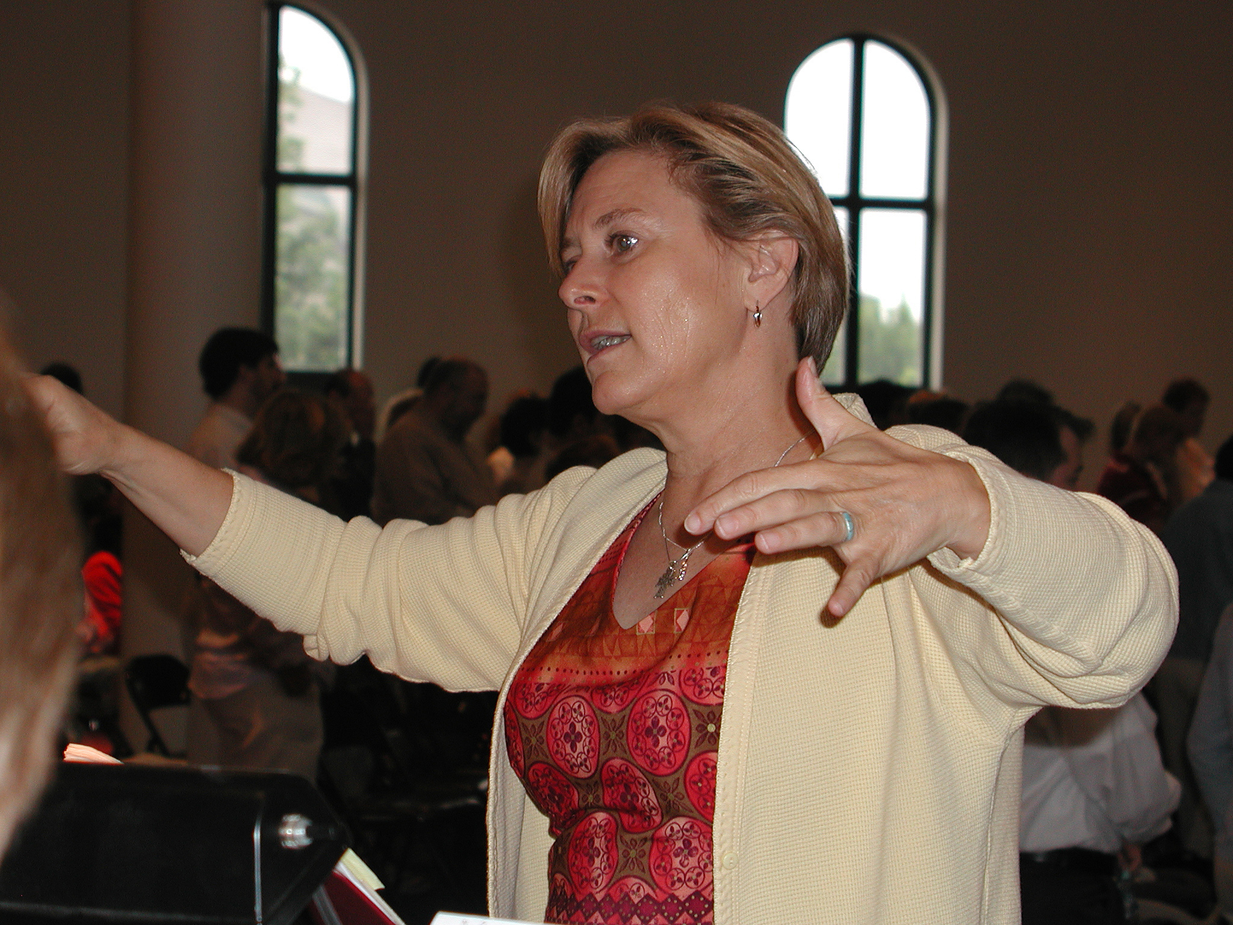
Building on the vision of the Gospel, healthy parish communities remember that the fundamental purpose of liturgical services is to worship God. The community strives to please God, not themselves -- and to consistently offer their best through worship that is holy, joyous, peaceful, thankful and enlivening.

3. Shared Leadership
⬥ Sharing /Delegating Responsibility  Leading Change
⬥ Functional Structures & Administration  Open Financial Practice & Reporting
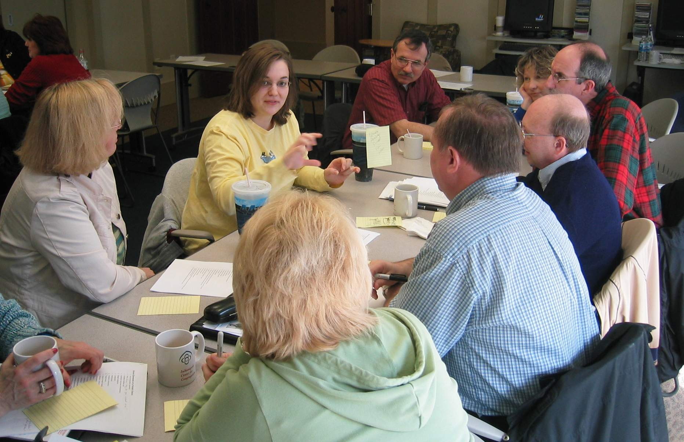
Healthy parishes craft administrative structures that are appropriate to the size and vision of the community. Ministries are defined, funded and equipped. Parish lay leaders see themselves as stewards of a Christian community collaborating with the rector to build health and vibrancy of the parish. They are NOT the parish business managers, trustees, owners, disinterested commentators and/or critics.

4. Open Communication
⬥ Consensus and Dialogue  Dealing with Conflict  Internal Communication Methods
Putting a collaborative leadership structure into action requires an ability to effectively communicate as a body. To do so, healthy communities work to establish a clear competency for consensus and dialogue, listening, and an ability to humbly speak the truth to one another. They seek and integrate multiple perspectives and marginal views. Then they consistently reinforce communication by appropriately harnessing multiple forms of spoken, written, visual and electronic communication forms.

5.Authentic Community
⬥ Atmosphere of love & honest fellowship  Entry & incorporation mechanisms
⬥ Connectedness to larger church  Appropriate facilities
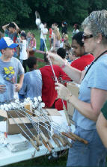
Enabled by an ability to dialogue openly, healthy parishes work hard to establish a culture where their identity as Orthodox Christians is lived out in such a manner that anyone who enters can see the hallmarks of Christian community: love, selfless giving, mutual encouragement, forgiveness, kindness, patience, hospitality and compassion. Christ can be recognized in their midst. People linger, smile and laugh. Healthy parishes think through assimilation paths for new members -- they make room. They see themselves not as independent congregations but as interdependent with other Orthodox communities.

6. Christian Formation
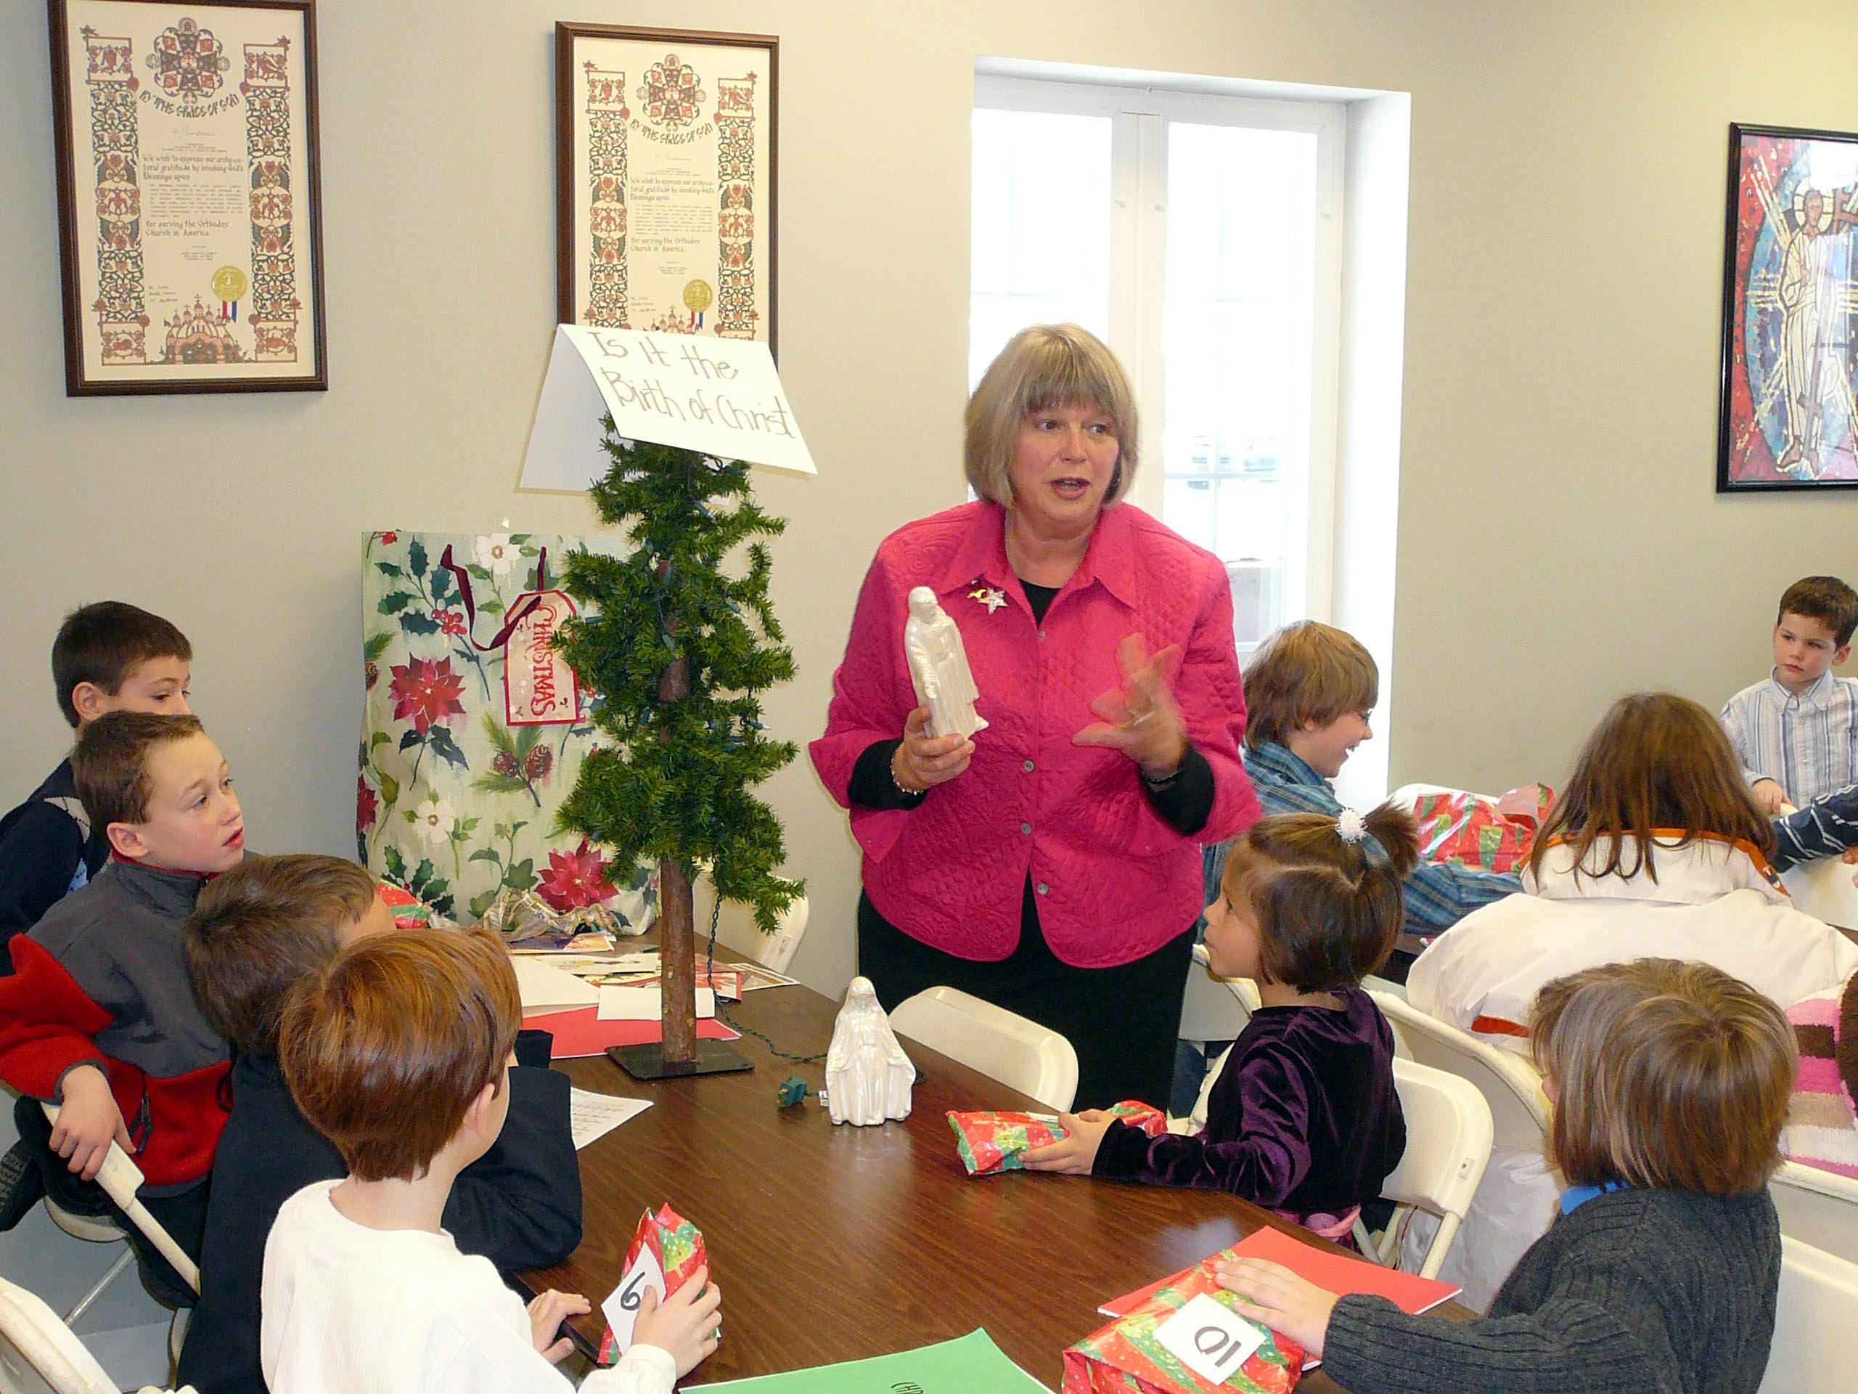
⬥ Orthodox spirituality  Education  Financial generosity
Supported by an appropriately comprehensive parish wide education effort, vibrant parish communities develop a commitment to lifelong learning and personal spiritual growth and change. Educational efforts are informational, formational and transformational - incorporating self study, experience events and mentoring in addition to books and classes. There is a clear focus on understanding and applying Orthodox spirituality. Stewardship is taught in the particular context of gratitude and generosity and love of neighbor.

7. Active Service
⬥ Discernment of gifts  Effective ministries
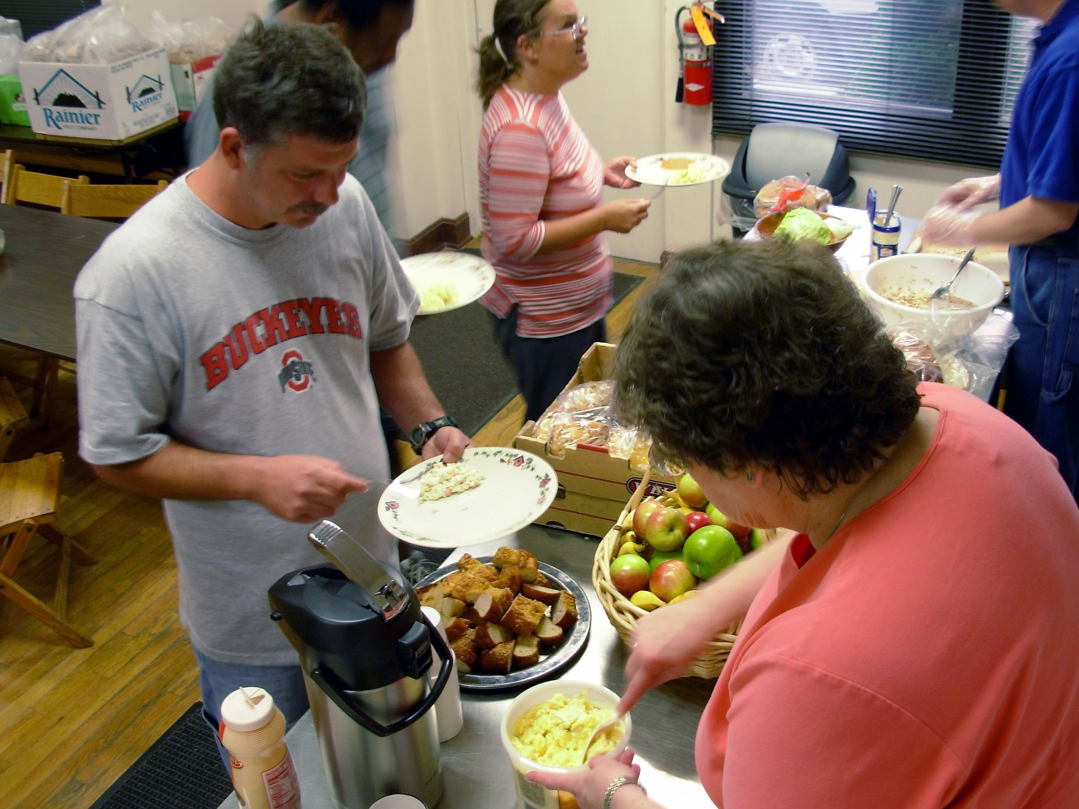
Clergy offer consistent endorsement to members as they discern how they can best contribute to the community. Members are regularly, actively encouraged to discover their gifts and to use them for God's glory. An appropriate set of internally and externally focused ministries provide ample opportunity for people to put these gifts and talents to work.

8. Spreading the Gospel
⬥ Parish evangelization atmosphere  Personal evangelization practice
⬥ Sensitivity to spiritual needs of others  External communication.
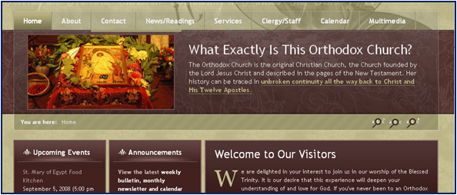
Healthy parishes do not see themselves as a closed community --keeping the Good News as "our little secret". They consistently work to shine their light to the community in which they reside with an evangelistic intent not primarily centered on numerical growth but a desire that others will be brought to Christ. The parish does not wait to get everything right on the inside before reaching out -- but consistently works to make things right on the inside while they reach out.

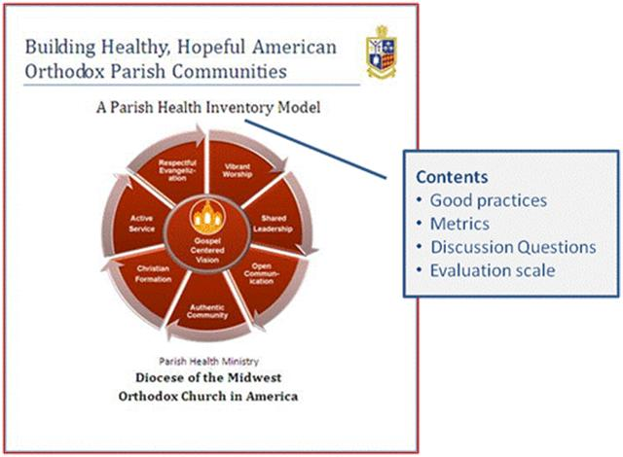
See Full Model
You can access the full description of the Diocese of the Midwest’s Parish Health Inventory Model at :

http://www.midwestdiocese.org/files/Parish%20Health/Inventory%20Docs/FocusareaV1final.pdf

