1 To pray daily.

2 To receive Holy Communion frequently.

3 To come to Holy Confession at least once a year.

4 To return to God the first fruits of the gifts He has bestowed on me.
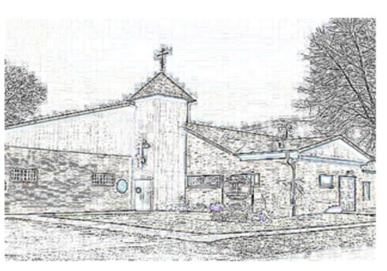

5 To assist in spreading the Good News of Jesus Christ in Canton and beyond.

6 To live out my personal commitment to Christ through loving service to others.
7 To support my parish, my diocese and national church of which I am an essential part.

Gross Annual Income Percentage of Annual Income Contributed Weekly to Holy Assumption Orthodox Church
 | 2% | 5% | 8% | 10%
$10,000 | $4.00 | $10.00 | $16.00 | $20.00
$15,000 | $6.00 | $15.00 | $24.00 | $30.00
$20,000 | $8.00 | $20.00 | $32.00 | $40.00
$25,000 | $10.00 | $25.00 | $40.00 | $50.00
$30,000 | $12.00 | $30.00 | $48.00 | $60.00
$35,000 | $14.00 | $35.00 | $56.00 | $70.00
$40,000 | $16.00 | $40.00 | $64.00 | $80.00
$45,000 | $18.00 | $45.00 | $72.00 | $90.00
$50,000 | $20.00 | $50.00 | $80.00 | $100.00
$55,000 | $22.00 | $55.00 | $88.00 | $110.00

As a responsible steward I/we commit for the year 2009, $ /week to
support the ministry of Christ at Holy Assumption Orthodox Church. Name:
Street address:
City: ZIP:

If you have a difficulty making a stewardship commitment, please call Fr XXXXXXXX at (123) 546-7890
Please return this to Holy Assumption Orthodox Church

as soon as possible.

Thank you,

The Stewardship Committee

Therefore, as the elect of God, holy and beloved, put on tender mercies, kindness,
humility, meekness, longsuffering; bearing with one another, and forgiving one another,
if anyone has a complaint against another; even as Christ forgave you, so you also must do. But above all these things put on love, which is the bond of perfection.
(Col 3:12-14)

Holy Assumption Orthodox Church
2027 – 18th St. NE
Canton, OH 44705

Please return this to Holy Assumption Orthodox Church

as soon as possible.

Thank you,

The Stewardship Committee

